"God Is At Home"
Published: 6/07/2016
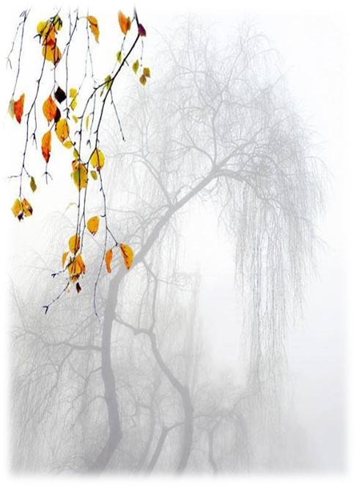
"God is at home. It is we who have gone for a walk." - Meister Eckhart

Dear Friends,
Winter is now fully upon us. Amidst all the cold and the wind, we can easily get a little dispirited and wonder whether the sun will ever shine again!
At such times, it’s good to enter within our souls and remember the Lord is within each of us—closer to us than we are to ourselves.

For if we cannot rediscover our ‘interior mansion’, as St Teresa of Ávila would say, then all our efforts at living the Gospel will be superficial. Worse, our witness will be hollow.
That is why I like the poetry of the late Swedish writer and psychologist Tomas Tranströmer (winner of the 2011 Nobel Prize for Literature). Tranströmer was a mystical observer of the sacred in the ordinary; someone who, although felled by a stroke 20 years ago and unable to speak, kept on communicating, even in the ‘winter’ of his life.
I especially love his poem Romanesque arches because it captures something of how we Christians must reach out to others. For it is from the depths of our inner humanity that we must witness, like Jesus, to the coming of the Reign of God.
A few of his lines suggest a way forward: ‘Don’t be ashamed to be a human being, be proud!’ A fundamental principle of the spiritual life is to accept one’s humanity graciously. To forgo self-hatred, and the opposite extreme position of grandiosity and narcissistic delusions about one’s self, is (in Ignatian terms) to accept one’s creaturehood.
Certainly, no evangelisation can take place if the evangeliser does not join the human race! And it is surprising how many people do not! We must never forget that we are disciples of an incarnate God. Consider the gaze of Mary on the tiny face of the infant Jesus. As Francis Webb put it: ‘The tiny, not the immense, will teach our groping eyes.’

Our God became one of us! That is our ultimate boast.
‘You’ll never be complete, and that’s as it should be.’ Catholic doctrine and dogma do not exhaust the gracious mystery of the Trinity. They are a ‘window’ into the heart of God—but we should not mistake the window’s ‘frame’ for the reality.
The majesty of Catholic teaching is that it opens us up to a vision beyond our wildest dreams. Televangelists may think they have the ‘answer’—Catholics take off their shoes because, like Moses, they know they are always in the awesome presence of Mystery.
The Angel—the signal of the transcendent—whispered to Mary in the Annunciation a message of joy.
Tranströmer imagines an angel whispering to each of us in the silence of our hearts: ‘Inside you one vault after another opens endlessly.’
To live a greater interiority and spirit of contemplation; to rejoice in our humanity as the greatest gift of a God who was not ashamed to become one of us; to rejoice in our incompleteness as a way towards truth and to let grace open up the hidden ‘vaults’ of our spirits—these are our hopes on the journey of faith.
Even in in the dark of winter, may we never forget Meister Eckhart’s wisdom: ‘God is at home. It is we who have gone for a walk.’

- Mark O'Connor fms

Romanesque arches

Tourists have crowded into the half-dark of the enormous Romanesque church.
Vault opening behind vault and no perspective.
A few candle flames flickered.
An angel whose face I couldn’t see embraced me
and his whisper went all through my body:
‘Don’t be ashamed to be a human being, be proud!
Inside you one vault after another opens endlessly.
You’ll never be complete, and that’s as it should be.’
Tears blinded me as we were herded out into the fiercely sunlit piazza,
together with Mr and Mrs Jones, Herr Tanaka and Signora Sabatini;
within each of them vault after vault opened endlessly.

- Tomas Tranströmer, Romanesque arches, translated by Robert Bly,
from The half-finished heaven: The best poems of Tomas Tranströmer.

